**PHARMACY COMPANY**

**DATABASE DESIGNE**

**REQUIRMENT ANALYSIS:-**

* Patient
* Medicine
* Bill
* Pharmacy
* Doctor
* Hospital
* Supplier
* Employee

**CONCEPTUAL SCHEMA:-**

PATIENT

MEDICIEN

EMPLOYEE

SUPPLIER

HOSPITAL

DOCTOR

PHARMACY

BILL

**LOGICAL SCHEMA:-**

PATIENT

MEDICIEN

EMPLOYEE

HOSPITAL

DOCTOR

PHARMACY

BILL

EMPLOYEE_NAME=

EMPLOYEE_ID=

NIC=

ADDRESS=

SALARY=

SUPPLIER_NAME=

SUPPLIER_ID=

CITY=

LOCATION

STATE=

PRICE=

SUPPLIER

HOSPITAL_ID=

NAME=

LOCATION=

STATE=

PIN_CODE=

CITY=

DOC_NAME=

HOSPITAL=

DOC_ID=

CONTACT=

ADD1=

ADD2=

PIC_CODE=

STORE_NAME=

STORE_ID=

CITY=

STATE=

LOCATION=

ADD1=

ADD2=

P_ID=

DOC_ID=

DRUG_ID=

QUANTITY=

BILL_ID=

MFG DATE=

DRUG_ID=

QUANTITY=

PRICE=

EXP DATE=

P_ID=

NAME=

CONTACT=

ADD1=

ADD2=

**SCHEMA REFIRMENT:-**

NO SCHEMA REFIREMENT

**PHYSICAL SCHEMA:-**

PATIENT

MEDICIEN

EMPLOYEE

HOSPITAL

DOCTOR

PHARMACY

BILL

EMPLOYEE_NAME=TEXT

EMPLOYEE_ID=NUMBER

NIC=NUMBER

ADDRESS=TEXT

SALARY=NUMBER

SUPPLIER_NAME=TEXT

SUPPLIER_ID=NUMBER

CITY=TEXT

LOCATION=TEXT

STATE=TEXT

PRICE=NUMBER

SUPPLIER

HOSPITAL_ID=NUMBER

NAME=TEXT

LOCATION=TEXT

STATE=TEXT

PIN_CODE=NUMBER

CITY=TEXT

DOC_NAME=TEXT

HOSPITAL=TEXT

DOC_ID=NUMBER

CONTACT=NUMBER

ADD1=TEXT

ADD2=TEXT

PIC_CODE=NUMBER

STORE_NAME=TEXT

STORE_ID=NUMBER

CITY=TEXT

STATE=TEXT

LOCATION=TEXT

ADD1=TEXT

ADD2=TEXT

P_ID=NUMBER

DOC_ID=NUMBER

DRUG_ID=NUMBER

QUANTITY=NUMBER

BILL_ID=NUMBER

MFG DATE=NUMBER

DRUG_ID=NUMBER

QUANTITY=NUMBER

PRICE=NUMBER

EXP DATE=NUMBER

P_ID= NUMBER

NAME= TEXT

CONTACT= NUMBER

ADD1= TEXT

ADD2= TEXT

**SECURITY DESIGN:-**

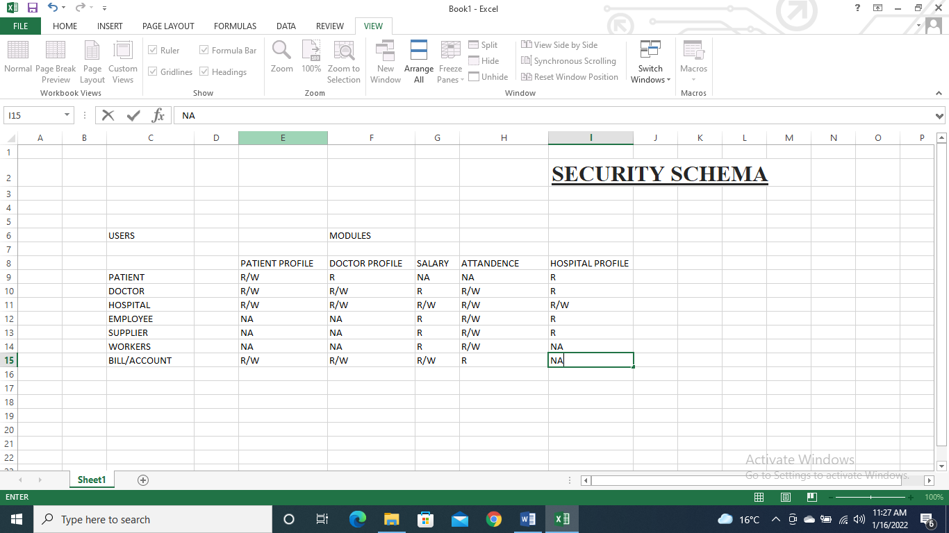

**DATA COLLECTION & DATA POPULATION:-**

